Baltic URO congress speakers:

1. Prof. Dr.med.Kurt G. Naber (DE)

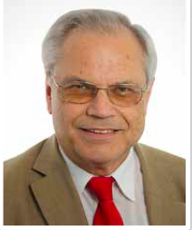

Assoc. prof. Urology at the Technical University of Munich School of Medicine, Head of the Urologic Clinic , St. Elisabeth Hospital in Straubing, a teaching hospital of the technical University of Munich, Germany.

Prof. naber was a president (1997-19990 of the Paul Ehrlich Society for Chemotherapy (PEC) in Germany, Austria and Switzerland, and President (1998-2000) of the Federation of European Societies for Chemotherapy and Infection (FESCI). He was the President of the 2nd European Congress of Chemotherapy 1998 in Hamburg, Germany. He is currently the President of the International Society of Chemotherapy (ISC) for Infection and Cancer (2005-2009) and he is Chairman of the UTI Commission of the ISC.
Prof. Naber is the author of more than 450 scientific articles and medical textbooks and serves on the editorial board of several journals. He is a member of numerous societies, including the Germany, European and American Urological Association (AUA), and the PEC, the German Society for infection, and the European Society for Clinical Microbiology and Infectious Diseases (ESCMID)

2.Dr. Zane Pilsētniece (LV)

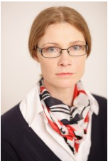
Urologist at the P. Stradins Clinical University Hospital.
Member of the Latvian Society of Urologists, Member of EAU.

3.MD, PhD, Dr.med.sc., Prof. Bashmakova Nadezhda

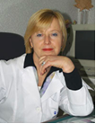
Chief obstetrician-gynecologist of the Ural Federal District, Director of the Ural scientific research institute of maternal and children health care.

Prof. Nadezhda Vasilievna Bashmakova, born on 22 April, 1948, graduated from the Sverdlovsk State Medical Institute in 1972. From 1972 until the present day, she has worked at the Ural Research Institute of Maternity and Childhood Protection under the Ministry of Health of the Russian Federation. First, she worked as a junior researcher in obstetrics and gynecology. After defending her candidate dissertation in 1981, she worked as a senior researcher and Director of the Institute’s Department of Obstetrics. In 1999, she defended her thesis for the degree of Doctor of Medicine titled “Non-Clinical Diagnostics and Prognosis of Perinatal Pathology on Model Population of Pregnant Women in a Major Industrial City.” In 1995, she was appointed as a Deputy Director for Scientific Research at the Federal State-Funded Institution “Ural Scientific Research Institute of Maternity and Childhood Protection” under the Ministry of Health of the Russian Federation. In 2000, she was awarded the title of Honorary Doctor of the Russian Federation. In 2001, she was awarded the title of professor. Since 2002, she’s been a chief obstetrician of the Ural Federal District. In 2013, she was appointed as a Director of the Institute. She is an author of 256 scientific papers,
and has supervised 32 Candidates of Medicine and 5 Doctors of Medicine. She participated as the principal investigator in 9 multicenter international clinical studies of drugs and medical devices. She is a member of the editorial boards of leading scientific journals in obstetrics and gynecology (Obstetrics and gynecology, Russian Bulletin for Obstetricians and Gynecologists, Status Praesens, Doctor’s Formula).

4. Prof. Dr.Med. V. Voshchula (BY)
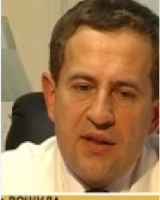
President of Belarusian Society of Urologists, Prof. of Belarusian Medical Academy of Postgradual Education, Minsk district clinical hospital, urological department, Member of EAU.

